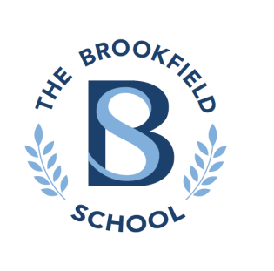
REMOTE LEAING POLICY
Remote Learning Policy

Rationale

In the event of a school closure, the school is committed to providing continuity of education to its pupils and will do so through a process of remote (distance) learning. Extensive remote learning would apply particularly in a situation in which the school is closed for an extended period of time, but a high proportion of pupils and teachers are healthy, and able to work as normal from home.

This policy does not normally apply in the event of short-term school closures (e.g. as a result of inclement weather) or a short-term pupil absence.

Remote learning may also be appropriate in situations when pupils, in agreement with the school, have a period of absence but are able to work at home, at least to some extent. This may apply where a student may have a longer-term illness, assuming pupils are able to complete school work at home. Another relevant instance would be if, following an infectious disease outbreak, pupils are self- isolating at home but are not suffering with any symptoms of disease.

Remote Learning for Individual Pupils

Assuming an absence has been agreed with the school, and the pupil in question is healthy enough to work from home, the school will provide work for pupils who are unable to attend in person. If this occurs for an individual pupil, the collation of work and communication with the parent/carer will be coordinated by the pupil’s form tutor or member of the Senior Leadership Team.

Though every case will have its own specifics, a rough guideline for the frequency of communication between school and parent/carer would be twice per week. Work will only be provided to pupils in this way if there is an agreed absence lasting more than one working week.

If a significant number of pupils are absent from school, but the school remains open, the Headteacher will decide whether the method of remote learning operated will take the form outlined here, or as outlined below.

Remote Learning in the Event of Extended School Closure

In the event of an extended school closure, the school will provide continuity of education in the following ways:

- Regular direct instruction from teaching teachers, with the ability of pupils to ask questions online (via email or MS Teams).
- Pupils to register in the morning and afternoon via MS Teams with their Form Tutor.
- The setting of work that pupils complete, written responses (if relevant) completed electronically or on worksheets.
- The assessment of work that is submitted to teachers electronically on which feedback is provided. Pupils and teachers are expected to have access to the Internet whilst at home. If a student does not have access to a computer, they will complete worksheets that are collected and returned with regular feedback.
- The setting of work in hard copy worksheets. The school recognises that some families may not have access to a computer/smart phone so hard copy worksheets will be sent out to all.

The primary platform the school will use to deliver continuity of education is Microsoft Office 365, accessible from anywhere with an Internet connection, which comprises:
- Microsoft Teams for communications & live sessions (accessed via the relevant app or desktop application)
- Microsoft Outlook (for email)
- Office applications, such as Word, Excel and PowerPoint

The school will also use CPOMS for communications recording and safeguarding.

The extent to which different methods of instruction are employed is likely to be determined by the length of any school closure and the ability of both pupils and teachers to participate in remote learning. The school reserves the right to vary the range of methods used to provide remote learning tasks, feedback and interaction, based on the particular circumstances of any closure and based on our experience.

Live Sessions
Microsoft Teams is a platform that allow for resources to be shared, teachers to provide exposition, and pupils to ask questions in ‘real-time’. Pupils will be provided with details of sessions, and will be expected to participate in them if they are asked and able to. Live sessions can be particularly helpful as they can help two-way communication, with pupils able to respond to teachers’ questions (and ask them).

Assessment

Providing timely and helpful feedback is a cornerstone of good teaching and learning, and whilst this may be more challenging with remote learning, teachers will endeavour to provide regular feedback to pupils on pieces of work that they are required to submit. Under normal circumstances, not all pieces of work are formally assessed by teachers and this would continue to be the case should the school employ remote learning.

Given the nature of the tasks, the type of feedback teachers can provide may not have the same format as marking an exercise book. Teachers are encouraged to ensure, when they set assessed work, that it is designed in such a way that meaningful feedback may be provided.

Possible methods may include:
- Providing whole class feedback rather than feedback on individual pieces of work (this is an effective way of providing feedback, supported by findings from educational research)
- Using the “Comments” function on online documents
- Sending a direct message to pupils with specific feedback / targets
- Feedback via form tutor contact

Expectations of Pupils

Assuming that a pupil is healthy and well enough to work, pupils will be expected to participate as fully as possible in the remote learning process, attending relevant live sessions, completing independent work, and submitting assessed tasks promptly and to the best of their ability. Pupils will also be expected to read and respond to communication from the school (e.g. an email from a Form Tutor) on a regular basis.

If pupils or parents have any questions about the nature of specific tasks set, these should be directed towards the tutor who will liaise with the specific subject area. If there are questions about a pupil’s overall workload (e.g. a pupil feels they are overwhelmed or falling behind), these should also be directed to the pupil’s tutor.

Teachers must work on the assumption that pupils will not necessarily have the full range of books and equipment that they would usually have in school. However, if advance notice is possible, teachers will provide pupils with any relevant equipment.

The school expects that most parents have internet access at home to access remote learning resources. If they do not, pupils can complete the worksheets that are sent out and these will be collected and replaced on a weekly basis. As a school, The Brookfield School will work to help pupils without connectivity or access to devices.

Expectations of Teaching Staff

Teachers should ensure they have effective internet and phone connectivity at home. If this is not available for any reason, teachers should consult with a member of SLT.

In order that we are providing a consistent approach, SLT will be responsible for overseeing the nature and frequency of tasks set and assessed within subject areas. All teachers should pay due care to the nature of tasks set, so that pupils have a range of activities to complete at home and are not exclusively working on a screen. Teachers are responsible for providing constructive feedback to their pupils in a timely manner.

In the event a teacher is unwell during a period of remote learning, it becomes the responsibility of the Headteacher or Assistant Headteacher to ensure work is set to her/his classes.

Teaching staff and form tutors should be available to contact parents if needed, by email or phone (NB: when phoning from personal devices, dialling 141 before the number will ensure the tutor’s own number is kept anonymous). Any issues that arise with this communication should be reported to SLT immediately.

If parents ask for additional work beyond that set as part of the requirements above, subject areas should have a bank of general resources available and point pupils and parents in that direction (e.g. BBC Bitesize).

Teaching staff should ensure that they have looked through specific instructions, watched walkthroughs, and made sure that they are familiar and comfortable with using Microsoft Teams in advance of lessons. It is recommended that they should try to have pre-prepared online lessons to deliver in the event of sudden closure. If teachers require support with any aspects of remote learning, they are encouraged to consult with a member of the Senior Leadership team.

Unless there are extenuating circumstances, teachers will be expected to be contactable remotely by colleagues, pupils and parents during the school day.

All communication should take place during usual office hours, with no expectation for colleagues to read or respond to emails/calls after 4.30pm. For those who are on part-time contracts, communication is expected only on the days on which they would usually work.

Communication must always occur via official school channels, and not through personal accounts or other websites. Permitted methods are:
- Email (using The Brookfield School email addresses only)
- Microsoft Teams

Inclusion – support for pupils with SEND, EAL and other learning needs

Teachers should ensure that work is differentiated as required for all pupils when setting online tasks. Advice can be sought from the Headteacher or Assistant Headteacher.

Pastoral Care & Safeguarding during school closure

In event of a school closure, the primary responsibility for the pastoral care of a pupil rests with their parents / carers. However, tutors (under the guidance of the Senior Leadership Team) should check in regularly to monitor both academic progress and their general wellbeing and record all contact using school systems. Checks should take place with both the pupils themselves and their parents/carers. Staff are expected to pass on feedback to Senior Leadership Team, particularly if there are concerns or a lack of communication.

Staff, pupils, parents and carers are reminded that the school’s Child Protection and Safeguarding Policy still applies to all interactions between pupils and teachers. In that policy, there are specifically prohibited behaviours and reporting obligations to which teachers must adhere, whether they are at home, in the community or at school.

Any safeguarding concerns must be logged by staff in the online CPOMS safeguarding system.

Reviewed: January 2023

Remote Learning Agreement


Pupils Responsible Use of Technology Policy
These 10 rules will keep everyone safe and help us to be fair to others.
- I will only use the school’s computers and tablets for schoolwork in school.
- I will only delete or look at my own files.
- I will keep my password secret from other pupils.
- I will not visit Internet sites I know to be banned by the school.
- I will only e-mail if my teacher has granted permission and to people in school usually (unless teacher directed as part of a lesson).
- The messages I send, or information I upload, will always be polite and sensible.
- I will not open an attachment, or download a file, unless I have permission or I know and trust the person who has sent it. Stop and think, BEFORE you click!
- I will not give my home address, phone number, send a photograph or video, or give any other personal information that could be used to identify me, my family or my friends, unless my teacher has given permission.
- I will never arrange to meet someone I have only ever previously met on the Internet or by email or in a chat room, unless my parent, guardian or teacher has given me permission and I take a responsible adult with me.
- If I see anything I am unhappy with or I receive a message I do not like, I will not respond to it but I will tell a teacher / responsible adult.
Pupil name:_____________________________________
I have read the school ‘10 rules for responsible use of technology’.
My teacher has explained them to me. I understand these rules are there to help keep me safe, and my friends and family safe. I agree to follow the rules.
This means I will use the computers, internet, e-mail, online communities, digital cameras, video recorders, and other ICT in a safe and responsible way.
I understand that the school can check my computer files, and the Internet sites I visit, and that if they have concerns about my safety, that they may contact my parent/carer.

Pupil’s signature_________________________ Date: ___/___/___

Parent/ Carer’s signature ______________________Date: ___/___/___

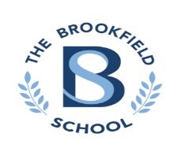
Pupil Code of Conduct

We respect ourselves, other people and our school.



We expect pupils to:
- Respect each other and show respect for adults.
- Wear our school uniform with pride!
- Demonstrate courtesy, care, commitment, cooperation and consideration in all they say and do.
- Make it as easy as possible for everyone to learn and for the teacher to teach, whether this takes place inside or outside the classroom.
- Keep our school clean and tidy so that it can be a welcoming place of which we can be proud.

Pupil’s signature_________________________ Date: ___/___/___

LIVE LESSONS TIP SHEET

Our basic rules for ‘live’ online lessons

- An adult should be present somewhere in the home during the lesson
- You are in either your dining room, living room or kitchen and not your bedroom.
- You should be dressed and ready – not in pyjamas!
- Please remember that the video conference is part of school. You must be respectful to staff and other pupils. School rules still apply! No swearing!
- You must not record video or take pictures of classmates or your teacher during your online sessions.
- Stay safe online – keep yourself, your classmates and your teacher safe.

How to join live lessons

- Your teacher should send you an invitation to join a meeting on Microsoft Teams, which will come through in an email
- Open the invitation and click “Accept / Yes”
- Go to your calendar – you should then see the lesson added on your calendar
- When it’s time for your lesson, click on “Join”
- You will have the option of using the app or joining through your web browser. Teams can work better if you download and use the app

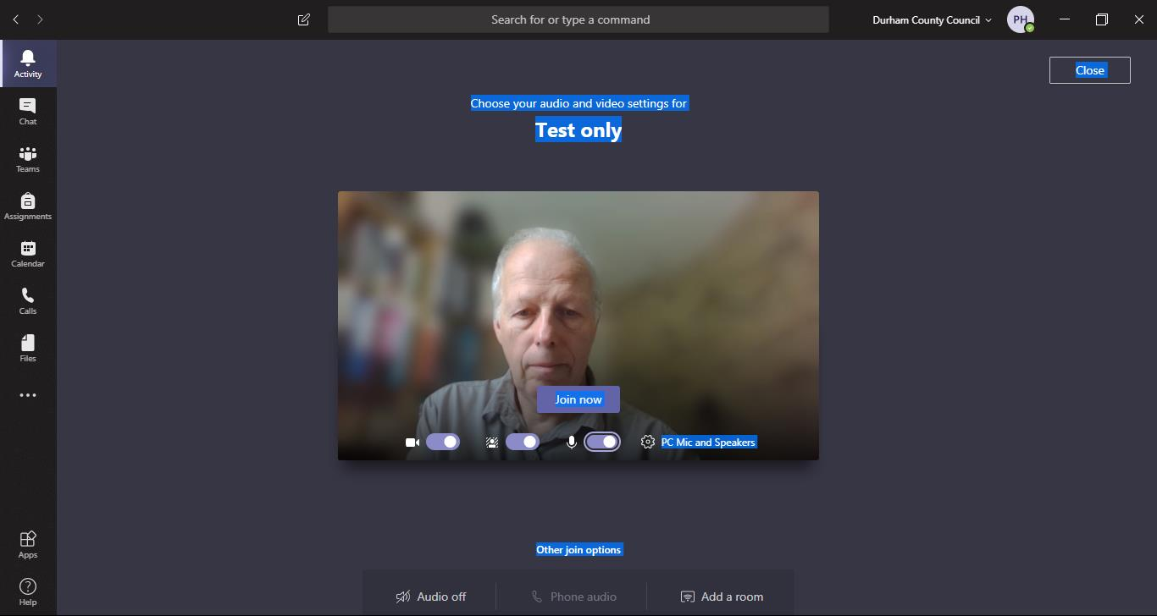

Start with your microphone on mute (turned off) otherwise it can get a bit noisy

It’s a good idea to blur your background so others can’t see your house!
It’s a good idea to blur your background so others can’t see your house!
Start with your microphone on mute (turned off) otherwise it can get a bit noisy

